Day 11. HTML assignment. Deployed

Design a contact us form with all fields as required.

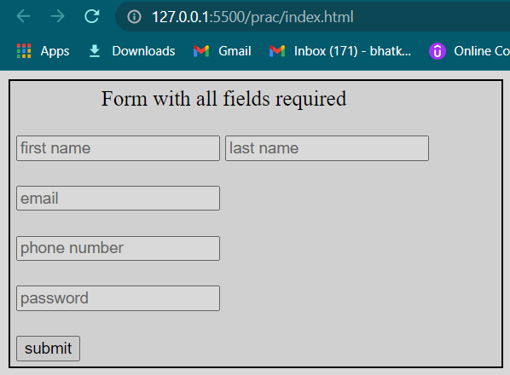

Use certain HTML elements to display the following in a HTML page.

* Programming Language
  + JavaScript
    1. Angular
    2. React
    3. Vue.js
  + Python
    1. Django Framework
    2. Flask Framework
  + Java
    1. Spring
    2. Maven
    3. Hibernate
* Database
  + MySQL
  + MongoDB
  + Cansandra

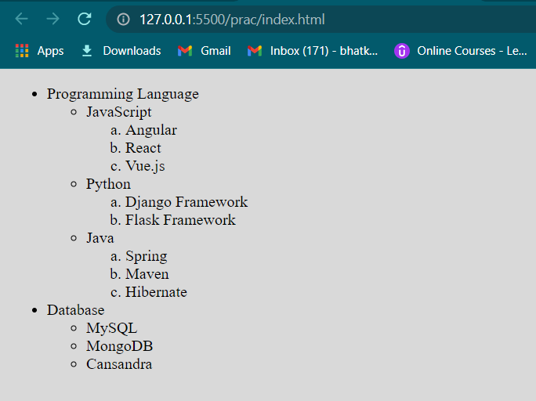

In the form, add two radio buttons with grouping them for employee type(Salaried and own business)

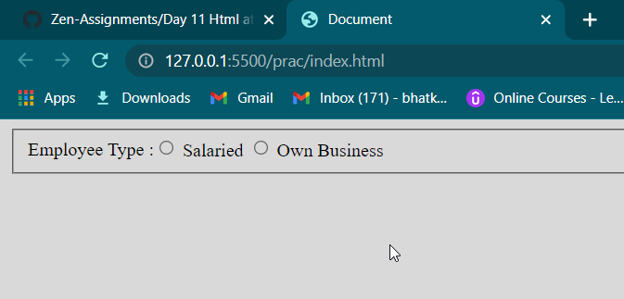

Use the table tag to design given image [Click here](https://www.bapugraphics.com/assets/img/port_upload_dir/table-4.jpg).

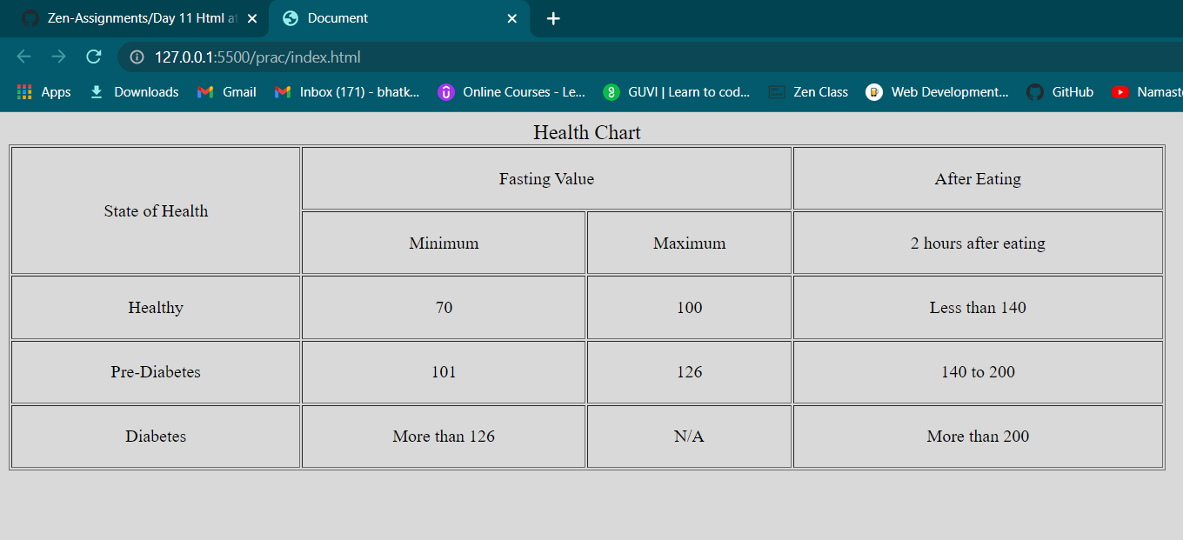

In your, HTML page add the below line and Highlight it without using any CSS.

* "HTML & CSS is awesome"

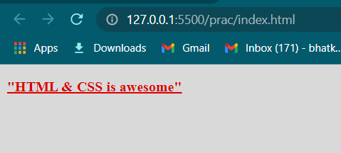

Create an HTML page, which should contain all types of input elements.

